PYTHON PROJECT

TOPIC:- BUS TICKET BOOKING

This Project is about the bus booking management here we can book ticket , cancel ticket, see booking

STEP 1:- C:\Users\151232\Desktop\project1.PNG

Click on the welcome button then another GUI will open which is given in step 2.

STEP 2:-

C:\Users\151232\Desktop\project.PNG

After clicking on book bus a another GUI will open which is given below

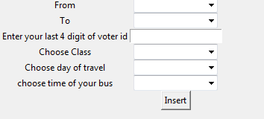

Fill the initials and click on insert button a dialog box will appear given below showing details

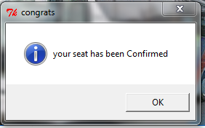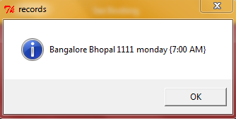

STEP 3:- On clicking on see booking a GUI will open fill the initials

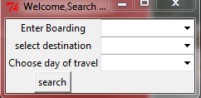

And it will show the booking

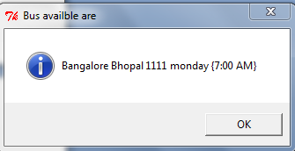

STEP 3:- On clicking on cancel button a GUI will open given below

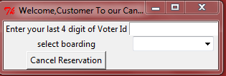

Enter the initials to cancel ticket click on cancel reservation button a GUI will open

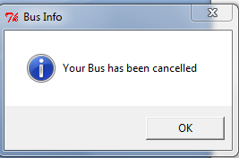

NOTE:- User should have to fill all entries if any field is empty there will be an error, shown an error dialog box below.

